Activity: How International Business Affects Everyday Life

To examine the ways in which you and your community rely on and are affected by international business, imagine that you are restricted to purchasing Canadian made goods and services. With a partner or in a small group, discuss how this restriction would affect each of the following:
- Your diet:

- Your entertainment:

- Your family’s transportation:

- Your overall quality of life:
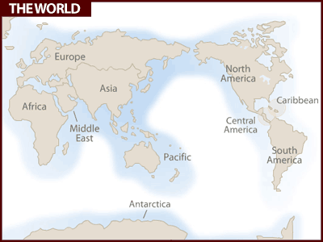
DISCOVERING THE BENEFITS OF INTERNATIONAL TRADE
Product 5: _________________

Is this a Canadian Product? Y__ N__

If yes, where else could I sell this product?______________________________________________________________________________________________

If no, could I sell this in Canada? Why? ____________________________________________________________________

Name one benefit this product achieves from participating in international trade. ______________________________________________________________________________________________________
Product 3: _________________

Is this a Canadian Product? Y__ N__

If yes, where else could I sell this product?______________________________________________________________________________________________

If no, could I sell this in Canada? Why? ____________________________________________________________________

Name one benefit this product achieves from participating in international trade. ______________________________________________________________________________________________________
Product 4: _________________

Is this a Canadian Product? Y__ N__

If yes, where else could I sell this product?______________________________________________________________________________________________

If no, could I sell this in Canada? Why? ____________________________________________________________________

Name one benefit this product achieves from participating in international trade. ______________________________________________________________________________________________________
Product 2: _________________

Is this a Canadian Product? Y__ N__

If yes, where else could I sell this product?______________________________________________________________________________________________

If no, could I sell this in Canada? Why? ____________________________________________________________________

Name one benefit this product achieves from participating in international trade. ______________________________________________________________________________________________________
Product 1: _________________

Is this a Canadian Product? Y__ N__

If yes, where else could I sell this product?______________________________________________________________________________________________

If no, could I sell this in Canada? Why? ____________________________________________________________________

Name one benefit this product achieves from participating in international trade. ______________________________________________________________________________________________________

