Chapter Notes: What is International Business?
Read the first section of Chapter 4, What is International Business (pgs. 113-127), in your textbook, and use the following organizer to help guide your note taking and then answer the following questions.
- What is International Trade?

Benefit | Description | Examples
access to markets |  | A jewellery manufacturer has all of jewellery stores in the United States to sell to, as well as Canada.
 | Canadian distributors buy products made with cheaper labour, and sell for less than Canadian produced products. Canadian businesses use offshore labour to make their goods. | Banks have outsourcing firms in India maintain their records; their furniture and equipment is made in China or Mexico and is cheaper than similar domestic products.
increased quality | Many countries are experts at producing or manufacturing specific products, or have better quality resources in certain areas. Canadian firms can use the superior resources or parts from other nations to create an overall superior product for the domestic market.
quantity of goods |  | The toy distributor has experienced product shortages during peak sale times and has worked hard to develop new sources of supply around the globe.
 | Many products are not made in Canada, or cannot be grown here. Global markets give businesses access to products and services they cannot get domestically. | The dentist orders specialized materials from sources in Germany and Austria. The drills are made in Switzerland; there is no Canadian manufacturer of specialized dental equipment.

- The five P’s of international business represent the benefits of getting involved with business outside Canada. Use the graphic organizer below to explain each of the five P’s.

Promotion
Product

Price
Proximity 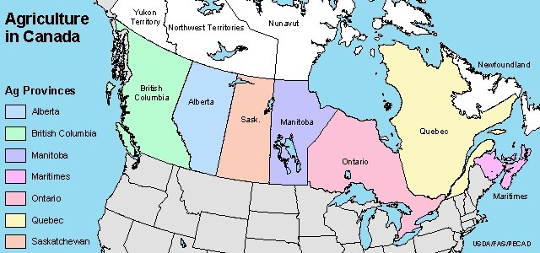
Preference
The Five P’s of International Business
- Explain what is meant by “social costs” of doing business internationally.

- Why would a business consider offshore outsourcing? What types of jobs are typically outsourced?

- List two examples of ethical problems that can result from offshore outsourcing?

- Explain sustainable development. Why is it important for a business to practice sustainable development?

- What barriers exist to international business? Why do they exist?

- What is a tariff? Explain the role of tariffs in managing trade with other countries.

- Explain the difference between tariff barriers and non-tariff barriers. Name two ways that a country can impose non-tariff barriers.

- Explain landed cost.

- List three reasons why governments impose excise taxes.

- What effect do currency exchange rates have on doing business internationally?

