Cropping an Image
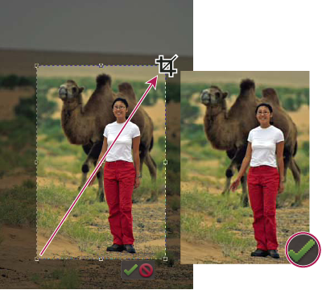

Crop a photo to remove some of the distracting background.
- In the Editor, select the Crop tool , or in the Organizer, select the Fix tab and click Crop.
- If you want to use a resolution other than that of the original photo, select one of the following options from the Aspect Ratio menu or specify new custom values in the Width and Height boxes in the options bar:
No Restriction

Lets you resize the image to any dimension.
Photo Ratio

Displays the original aspect ratio of the photo when you crop. The Width and Height boxes show the values that are used for the cropped image. The Resolution box allows you to change the image resolution.
Preset Size

Specifies a preset size for the cropped photo. If you want your final output to be a specific size, such as 4 x 6 inches to fit a picture frame, choose that preset size.
Note: When you specify values for the Width and Height boxes, the Aspect Ratio menu changes to Custom.
- (Editor) Drag over the part of the image you want to keep. When you release the mouse button, the crop marquee appears as a bounding box with handles at the corners and sides.
- (Optional) Adjust the crop marquee by doing any of the following:
  - To change the preset size or aspect ratio, choose new values from the Aspect Ratio menu in the options bar.
  - To move the marquee to another position, place the pointer inside the bounding box and click-drag, or hold down Alt and use the arrow keys to move the marquee.
  - To resize the marquee, drag a handle. (If you choose No Restriction from the Aspect Ratio menu, you can constrain the proportions while scaling by holding down Shift as you drag a corner handle.)
  - (Editor) To swap Width and Height values, click the Swap icon in the options bar.
  - (Editor) To rotate the marquee, position the pointer outside the bounding box (the pointer turns into a curved arrow ), and drag. (You can’t rotate the crop marquee for an image in Bitmap mode.)
Note: You can change the color and opacity of the crop shield (the cropped area surrounding the image) by changing the Crop tool preferences. Choose Edit > Preferences > Display & Cursors and specify a new Color and Opacity value in the Crop Tool area of the Preferences dialog box. If you don’t want to see a colored shield while cropping, deselect Use Shield.
- Click the green Commit button located in the lower-right corner of the marquee, or press Enter to finish the cropping. If you want to cancel the cropping operation, click the red Cancel button or press Esc

