PhotoShop

Activity #1 - Rotate or flip an item
You can rotate or flip a selection, a layer, or an entire image. Make sure to choose the correction command depending on the item you want to rotate or flip.
- In the Editor, select the photo, layer, selection, or shape you want to rotate or flip.
- Choose Image > Rotate, and choose one of the following commands from the submenu:
90° Left, Layer 90° Left, or Selection 90° Left

Rotates the photo, layer, or selection a quarter-turn counterclockwise. (Rotate Selection is only available when you have an active selection in an image.)
90° Right, Layer 90° Right, or Selection 90° Right

Rotates the photo, layer, or selection a quarter-turn clockwise.
180°, Layer 180°, or Selection 180°

Rotates the photo, layer, or selection a half-turn.
Custom

Rotates the item by the amount you specify. If you select this option, enter the number of degrees you want to rotate the item by, and the direction in which you want to rotate the item.
Note: A positive number rotates the object clockwise, and a negative number rotates the object counterclockwise.
When you are finished, click OK.
Flip Horizontal, Flip Layer Horizontal, or Flip Selection Horizontal

Flips the photo, layer, or selection horizontally.
Flip Vertical, Flip Layer Vertical, or Flip Selection Vertical

Flips the photo, layer, or selection vertically.

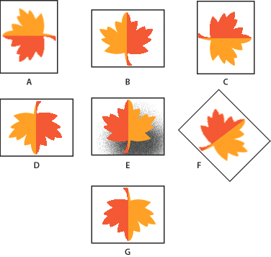
Rotating an image
A. Rotate 90° left
B. Flip Horizontal
C. Rotate 90° right
D. Rotate 180°
E. Original image
F. Free rotate
G. Flip Vertical

*You can also Skew, Distort and change perspective of your photo
Choose the Image drop down menu, Transform and then click on Skew, Distort or Change Perspective.

