The Income Statement and its Components

What is an income statement? __________________________________________________________________________________________________________________________
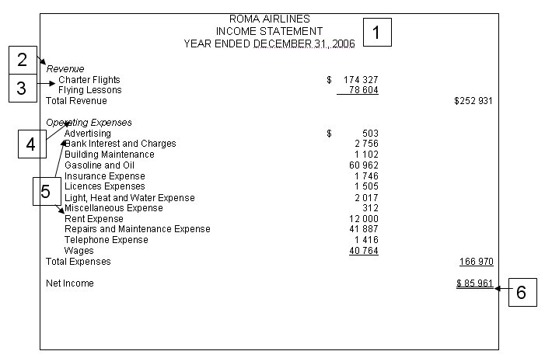
- The________________ gives the:
  - _________ of the business;
  - name of the __________________;
  - ___________________ _______________ for which the figures have been accumulated.
- The ___________________ section shows an ______________ in equity resulting from the proceeds of the sale of goods or ______________ in the ordinary course of business. The __________________ are usually placed in ______________________ order.
- __________ types of revenue are shown in the ______________ for ROMA AIRLINES.
- The ___________________ section shows __________________ in equity resulting from the ______________ of the goods or services used to produce the _________________. The expenses are usually placed in _______________________ order.
- ________________ are shown in ___________________.
- The Net ______________ or Net ____________ figure. Net _____________ is not cash. It is the difference between total revenues and total expenses, if the _______________ are greater than the _____________. In this case a net income is the result. If total expenses are greater than total revenue, the company would suffer a net ____________ for the period.

Uses of the Income Statement
- By _________________ and ___________________: the income statement tells the owners or managers if their business is earning profit. The data from the accounts contained in the income statement can be compared from year to year and decisions can be made according to them.
- By _____________________: financial statements inform bankers of the ability of the company to pay back its debts.
- By _______________________________________: The income statement must be sent to the government along with the owner’s income tax return.

Other Terminology:
Fiscal Period: ___________________________________________________________________________________________________________________. All fiscal periods for an individual business are the same length. This period is usually one year. The fiscal period does not have to run from January to December. It can run for 12 consecutive months in the year.
The Time Period Concept:

The Matching Principle:

Unit 3: Income Statement Transactions (T – Account, Trial Balance, Formal Journal and Ledger)

Activity 3: The Income Statement

Complete the following assignment and submit your work to your teacher.
- Using the template and the following expanded ledger accounts, create an income statement for Compu-Parts Inc (owner: Andrea Muldoon). Date the Income Statement for the year ended December 31st, 2006. Be sure to place the accounts in the correct order and provide a correct format.
- Use a formula to determine the net income/net loss of the fiscal period and the total revenues/expenses.
- Explain, with the net income/loss obtained, how this figure would affect the capital account of the company (increase or decrease).
Accounts Balances  Accounts payable 31255  Accounts Receivable 7540  Automobile 41520  Bank 31600  Beginning Capital 99000  Building 65000  Car Expense 13600  Commissions Earned 42590  Drawings 7520 | Accounts Balances  Equipment 17800  Fees Earned 74175  General Expense 3985  Land 74560  Loan Payable 21500  Mortgage Payable 32480  Postage Expense 415  Rental Expense 7640  Wages Expense 29820

